**JOMO KENYATTA UNIVERSITY OF AGRICULTURE AND TECHNOLOGY**

**Bsc. COMPUTER SCIENCE 2.2**

**DESIGN AND IMPLEMENTATION OF COMPUTER APP**

**SOFTWARE PROPOSAL**

GROUP MEMBERS:

1. SCT211-0069/2022 – Methusella Nyongesa
2. SCT211-0006/2022 – Chrispin Maina
3. SCT211-0071/2022 – Gift Nestah
4. SCT211-0038/2021 – Oyoo Felix
5. SCT211-0765/2022 – Meshack Otieno

What the software will do:

1. Manage data and information in a hospital.
2. Provide patient’s information on diagnosis, tests, dosage and treatment history.
3. Store staff data and information which includes medical personnel such as Doctors, Nurses and Clinical Officers.
4. Store drug details and data, supply records, consumption and utilization.

Potential clients and users of our Hospital Software system are:

1. Hospitals, Dispensaries, Clinics and health research institutions.
2. Doctors, Health Researchers and Medical personnel in general.

Functional Requirements:

1. Patient Management:

* Insert Patient Record: Allows users to enter and store patient information including diagnosis, tests, dosage and treatment history.
* Update Patient Record: Enable users to modify existing patient records.
* Retrieve and Display Patient Data: Provide the ability to retrieve and display patient information in a table format.

1. Drug Management:

* Insert Drug Entries: Allow users to add new drugs to the database.
* Retrieve and Display Available Drugs: Provide a list of available drugs in the hospital for easy reference.
* Store Drug Usage Information: Track data on drug consumption, usage and utilization within the hospital.

1. Staff Management:

* Store staff information: Maintain data and information on medical personnel including doctors, nurses and clinical officers.
* Retrieve and Display Staff Data: Allow users to retrieve and display details of medical personnel for reference and management purposes.

Non-Functional Requirements:

1. Operating System and Development Environment:

* We shall be using the Windows Operating System as the platform for running the software.
* We shall also utilize the VB.NET framework for developing the application.
* We shall also employ SQL database for data storage and management. Moreover, we shall use ADO.NET for integration with the SQL database.
* We shall develop the software using Visual Studio IDE for VB.NET development.

1. User Interface:

* We shall design a user-friendly interface that allows users to easily navigate and perform task.
* We shall also include data validation to ensure accuracy and integrity of the entered data.

1. Scalability and Extensibility:

* We shall design the software architecture to be scalable allowing for future expansion and addition for new features.
* We shall use design principles to facilitate easy maintenance and extension of the software.

**FEASIBILITY STUDY**

The feasibility study aims to assess the viability and practicality of implementing the propose Hospital Software System by evaluation of various factors such as technical, economic, operational and schedule aspects:

1. **TECHNICAL FEASIBILITY**

The proposed Hospital Software System involves the utilization of VB.NET framework, SQL database and ADO.NET integration for development. These technologies are widely used and supported, ensuring the availability of resources and expertise for implementation. The development tools such as Visual Studio IDE offer robust features for software development. Additionally, the compatibility with the Windows Operating System ensures seamless integration with the existing infrastructure.

1. **ECONOMIC FEASIBILITY**

The economic feasibility of the Hospital Software System is evaluated based on the cost of development, maintenance and Return of Investment (ROI). The initial development cost includes software licenses, development tools and human resources. However, the long-term benefits outweigh the initial investment. The software streamlines hospital operations, enhances efficiency in patient management, and optimizes drug inventory, leading to cost savings in the long run. Moreover, potential revenue generation from selling the software to clinics, hospitals and research institutions enhances economic feasibility.

1. **OPERATIONAL FEASIBILITY**

Operational feasibility examines whether the proposed Hospital Software System aligns with the operational requirements and goals of the healthcare institutions. The system offers comprehensive functionalities for patient management, drug inventory, and staff administration, addressing key operational challenges in healthcare facilities. The user-friendly interface facilitates easy adoption and navigation for medical personnel, ensuring minimal disruption to existing workflows. Moreover, the scalability and extensibility of the software allow for future enhancements and adaptation to evolving operational needs.

1. **SCHEDULE FEASIBILITY**

The scheduling feasibility assesses the timeline and resources required for the development, testing and deployment of the Hospital Software System. A detailed project plan outlines the tasks, milestones and resource allocation through the software development lifecycle. The phased approach ensures efficient utilization of resources and timely delivery of project milestones. Additionally, collaboration among team members and effective communication channels expedite the development process, ensuring adherence to the project schedule.

**SCHEDULE**

1. **Project Initiation (Week1):**

We define project scope, objectives and requirements. We also identify group members and assign roles and responsibilities amongst us.

1. **System Analysis and Design (Week 2):**

We analyze on existing hospital processes and workflows. We also define the system architecture, entity relationships and database schema. Moreover, we develop user interface wireframes, discuss on the functional and non-functional requirements.

1. **Development Phase1 (Week 3):**

We shall set up the development environment including Visual Studio IDE and SQL server. We shall also implement user authentication and authorization features. Develop basic CRUD functionalities for patient management module. Create database tables for patients, medical personnel, and drugs.

1. **Development Phase2 (Week 4):**

We shall implement drug management functionalities including updating, adding and searching drugs. Develop staff management module for storing and retrieving personnel information. Integrate ADO.NET for database connectivity and data manipulation. Conduct unit testing and debugging of developed modules.

1. **Development Phase3 (Week 5):**

We shall implement laboratory management functionalities for lab tests data entry and retrieval. Enhance user interface for improved usability and navigation. Integrate data validation mechanisms to ensure data integrity. Develop reporting features for generating patients reports and drug usage statistics.

1. **Testing and Quality Assurance (Week 6):**

We shall conduct comprehensive system testing including functional, integration, regression and testing. Identify and resolve software defects and performance issues. Prepare user documentation and training materials.

1. **Deployment and Training (Week 7):**

We shall install and configure the software on designated servers and client machines. Conduct training sessions for end users. Provide ongoing support and maintenance mechanisms.

1. **Post-Development Review and Evaluation (Week 8):**

We shall gather feedback from users regarding system performance and usability. Document post-deployment issues and resolutions. Finalize project documentation and archive project artifacts.

DESIGN

1. Interface Design



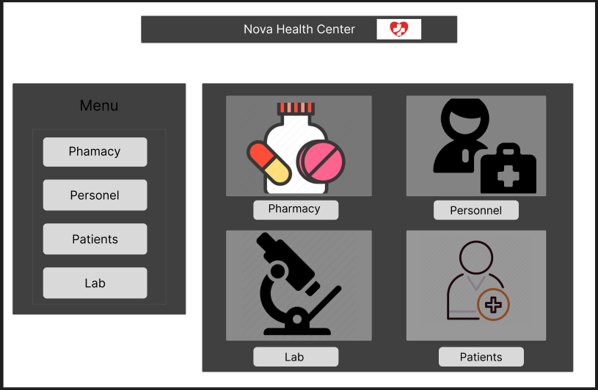

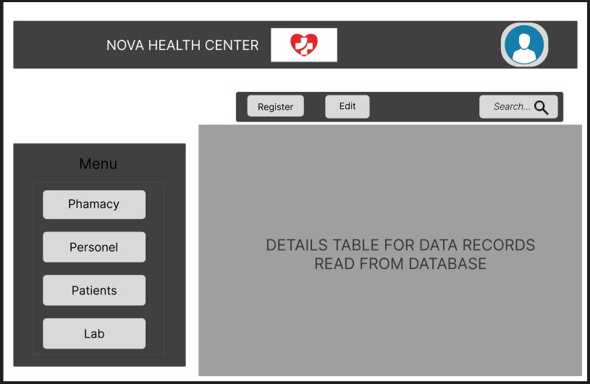

2.Program Design

Log In

Home –

Menu:-

Patients

Pharmacy

Lab

Personnel

Profile:-

Name

Settings

Logout

Patients:-

Side Menu:-

Patients

Pharmacy

Lab

Personnel

Patients Data Table

Add, Update, Search

View patient's history

Pharmacy:-

Side Menu:-

Patients

Pharmacy

Lab

Personnel

Drugs and Medicine Data Table

Add, Update, Search

Lab:-

Side Menu:-

Patients

Pharmacy

Lab

Personnel

Lab Tests Data Table

Add, Update, Search

Personnel:-

Side Menu:-

Patients

Pharmacy

Lab

Personnel

Personnel Data Table

Add, Update, Search

3. Database Design

The entities’ relationship will be as follows:-

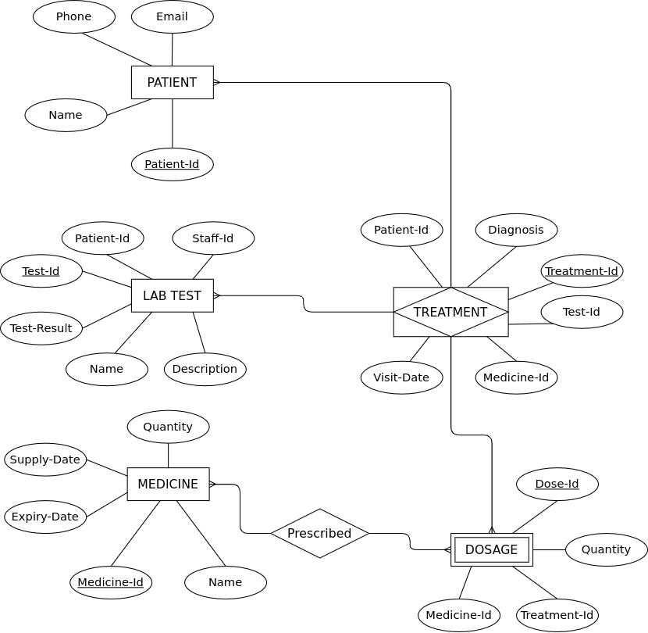

4. FLOWCHARTS

MEDICAL PERSONNEL FLOWCHART

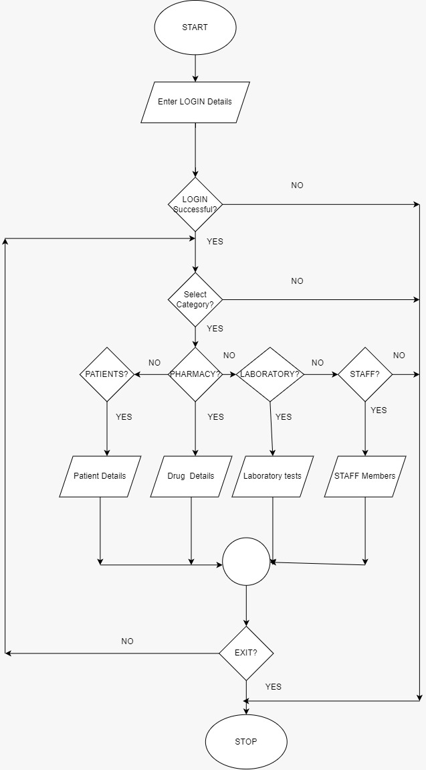

PATIENT FLOWCHART

Same to as Laboratory, Pharmacy and Staff Departments

